




CENTER FOR SKILL AND ENTREPRENEURSHIP DEVELOPMENT
(CSED)
INDUSTRIAL INTERNET OF THINGS

PROGRAM CODE: IIOT-4
PROGRAM NAME: DEEP LEARNING
PROJECT NAME: Road Traffic Flow Forecasting with LSTM

GROUP ID: BT_DL_23
PROJECT ID: DL-023
SECTION: D
MENTOR NAME: MR.RAUSHAN RAJ SIR

TEAM MEMBERS
S. No. | Name | Student ID
1 | AKSA IMAN (T.L.) | BCS2024316
2 | SACHIN | BCS2024275
3 | NIHARIKA TONDAN | BCS2024313
4 | ANUBHAV KUMAR | BCS2024314
5 | PANKAJ YADAV | BCS2024317
6 | PRIYANSHU YADAV | BCS2024318
7 | ANSHIKA BHARDWAJ | BCS2024321
8 | KRRISH ROHALA | BCS2024322
9 | AYUSH RATHORE | BCS2024326
10 | SMIRITI KUMARI | BCS2024327
11 | MOHAMMAD AYAN | BCS2024329
12 | HEMANT RATHORE | BCS2024330
13 | SHREY | BCS2024331
14 | VISHAL BABU | BCS2024333

INDEX

1. Introduction | 04
2. Problem Statement | 05
3. Objective of Project | 06
4. Methodology | 07-08
5. Literature Review | 09
6. Explanation of Project (Working) | 10
7. Workflow | 11
8. Program | 12-18
9. Result & Discussions | 19
10. Snippets of UI / Output | 20
11. Future Scope | 21
12. Conclusion | 22

1. Introduction
Road Traffic Flow Forecasting with Long Short-Term Memory (LSTM) is a deep learning-based project designed to estimate future traffic conditions by studying historical traffic data. Traffic flow changes over time because of vehicle demand, working hours, road capacity, weather, special events, and other factors. Predicting these changes can support better planning and traffic management.
Traffic congestion is a common challenge in growing cities. It can increase travel time, fuel consumption, vehicle emissions, and stress for road users. Traditional traffic monitoring mainly describes current conditions, while forecasting attempts to estimate what traffic may look like in the next time interval. Reliable forecasts can help road authorities and commuters prepare for busy periods.
This project uses Long Short-Term Memory (LSTM), a type of recurrent neural network designed to learn patterns in sequential data. LSTM networks use memory cells and gates to retain useful information from earlier observations. This makes them suitable for time-series tasks such as traffic-volume forecasting.
The system takes historical traffic measurements, such as vehicle count or traffic volume recorded at regular intervals, and uses them to train an LSTM model. After training, the model generates predictions for future traffic flow. The actual and predicted values can then be compared using graphs and evaluation measures.
The project aims to demonstrate how deep learning can be applied to transportation data. It can serve as a foundation for more advanced intelligent transportation applications, including congestion alerts, adaptive signal planning, and real-time traffic monitoring when connected to suitable live data sources.

2. Problem Statement
Traffic congestion is one of the major problems in urban and semi-urban areas. The number of vehicles is increasing, while road capacity and traffic infrastructure may not grow at the same rate. Sudden changes in traffic volume can lead to delays, fuel wastage, air pollution, and inefficient use of road networks. Traffic managers need timely information to understand and prepare for changing traffic conditions.
Many basic traffic monitoring systems focus on displaying present traffic conditions. However, knowing the current vehicle count does not always provide enough information to anticipate the traffic situation in the coming minutes or hours. Traffic volume also contains time-dependent patterns, such as daily peak hours and recurring variations, which can be difficult to model using simple approaches.
Therefore, there is a need for a data-driven forecasting system that can learn temporal patterns from historical traffic observations and estimate future traffic flow. This project addresses the problem by developing an LSTM-based time-series forecasting model.
The proposed system focuses on the following problems:
- Difficulty in estimating future traffic volume from current observations alone.
- Recurring peak-hour congestion and variations in traffic flow.
- Time wastage and increased fuel consumption caused by unexpected congestion.
- Need to identify temporal patterns in historical traffic measurements.
- Need for an understandable way to compare actual traffic values with model predictions.
- Need for a forecasting approach that can learn sequential dependencies in traffic data.
The project uses historical traffic data to train and evaluate an LSTM model. Its output is a forecast of traffic flow for a future time step or time window. The quality of the forecast depends on the dataset, its features, preprocessing, and model configuration.

3. Objective of the Project
The primary objective of the Road Traffic Flow Forecasting with LSTM project is to develop a deep learning-based system that analyzes historical traffic data and predicts future traffic volume.
- To collect and understand historical road traffic data.
- To preprocess traffic data and prepare it for time-series modelling.
- To identify patterns and trends in traffic flow over time.
- To build an LSTM model for forecasting future traffic volume.
- To train and test the model using suitable historical observations.
- To compare actual traffic values with predicted values.
- To evaluate forecasting performance using suitable error metrics.
- To visualize traffic trends and prediction results through graphs.
- To provide a foundation for intelligent and data-driven traffic management.
The project also aims to develop an efficient forecasting workflow that can learn from previous traffic conditions and identify time-based changes in traffic flow. By using LSTM, the system can consider sequential observations instead of treating every traffic record as an unrelated value.
Another objective is to support future smart transportation systems by providing useful information about expected traffic volume. The predictions may help traffic authorities and transportation planners understand recurring busy periods and plan suitable traffic-management strategies. The project is an analytical forecasting prototype and does not directly control traffic signals.

4. Methodology
The methodology follows a systematic sequence of stages, beginning with data collection and ending with prediction and evaluation. Each stage prepares the traffic data or improves the reliability of the forecasting process.

1. Data Collection
- Obtain a historical traffic dataset from a public dataset source or an available traffic-recording system.
- Use a time column and a traffic-flow measure such as vehicle count or traffic volume.
- Where available, include additional attributes such as road segment, day, hour, weather, or vehicle category.
- Check the dataset documentation to understand the meaning and units of each feature.

2. Data Preprocessing
- Load the dataset using Pandas and inspect its rows, columns, and data types.
- Convert the timestamp column into a datetime format and sort records chronologically.
- Handle missing or invalid traffic observations using an appropriate method.
- Remove duplicate records and check for unusual values.
- Scale the traffic-volume feature, for example with MinMaxScaler, to support stable model training.

3. Exploratory Data Analysis (EDA)
- Plot traffic volume over time to observe trends and sudden changes.
- Compare traffic flow by hour, day, or other available time features.
- Identify recurring peak periods and possible seasonal patterns.
- Use histograms and line graphs to understand the distribution of traffic observations.

4. Sequence Creation
LSTM models expect sequential input. The preprocessed traffic series is therefore converted into sliding windows. For example, a model may use the previous 12 observations to predict the next observation. The window size should be selected according to the time interval and dataset.

5. Model Building
- Create an LSTM network using TensorFlow/Keras.
- Add an LSTM layer to learn temporal dependencies from the input sequences.
- Add a Dense output layer to produce the forecasted traffic value.
- Compile the model using an optimizer such as Adam and a regression loss such as Mean Squared Error.

6. Model Training and Testing
- Split the time-series data chronologically into training and testing portions.
- Do not randomly shuffle time-series observations, because this can cause future information to enter the training data.
- Train the model on the training sequences and monitor its loss.
- Evaluate predictions on the later test period that was not used for training.

7. Model Evaluation
- Mean Absolute Error (MAE) measures the average absolute prediction error.
- Mean Squared Error (MSE) measures the average squared error.
- Root Mean Squared Error (RMSE) expresses error in the target variable's unit.
- Plot actual and predicted traffic values to visually inspect model performance.

8. Prediction and Visualization
The trained model receives the most recent sequence of traffic observations and predicts the next traffic value. Predictions are converted back to the original scale and displayed with a line graph. The output should be interpreted as an estimate, not a guarantee of future traffic conditions.

9. Deployment (Optional)
The model can be connected to a simple web interface using Flask or Streamlit. A user may select a road segment or provide recent traffic observations and view the forecast. Real-time deployment requires a reliable live traffic-data source and regular model monitoring.

5. Literature Review
Traffic flow forecasting has been studied using statistical, machine learning, and deep learning methods. Traditional time-series techniques, including autoregressive models, have been used to describe traffic variation over time. These approaches can provide useful baselines, but they may have limitations when traffic patterns are highly nonlinear or contain complex temporal dependencies.
Machine learning methods such as Support Vector Regression, Decision Trees, and Random Forests have also been applied to traffic prediction. These methods can learn relationships between input features and traffic volume. Their performance depends on the quality of the input features and the way temporal information is represented.
Deep learning approaches have gained attention because they can learn complex patterns from large sequential datasets. Recurrent Neural Networks (RNNs) are designed for sequence data, but standard RNNs may have difficulty retaining information over long sequences. Long Short-Term Memory networks were introduced to address this issue through gated memory cells.
LSTM has consequently been explored for time-series forecasting tasks, including traffic-flow prediction. It can learn from previous traffic observations and model temporal relationships. However, model performance is not guaranteed: it depends on data quality, observation frequency, sequence length, network design, and the evaluation method.

Key observations from existing work
- Historical traffic observations contain temporal patterns that can support forecasting.
- Traffic flow may show recurring variations across hours and days.
- LSTM networks are designed to learn sequential dependencies in time-series data.
- Chronological train-test splitting is important for a fair time-series evaluation.
- Forecasting accuracy should be reported with numerical metrics and actual-versus-predicted plots.
- External factors such as weather, incidents, road works, and special events may influence traffic and can be considered in future extensions.
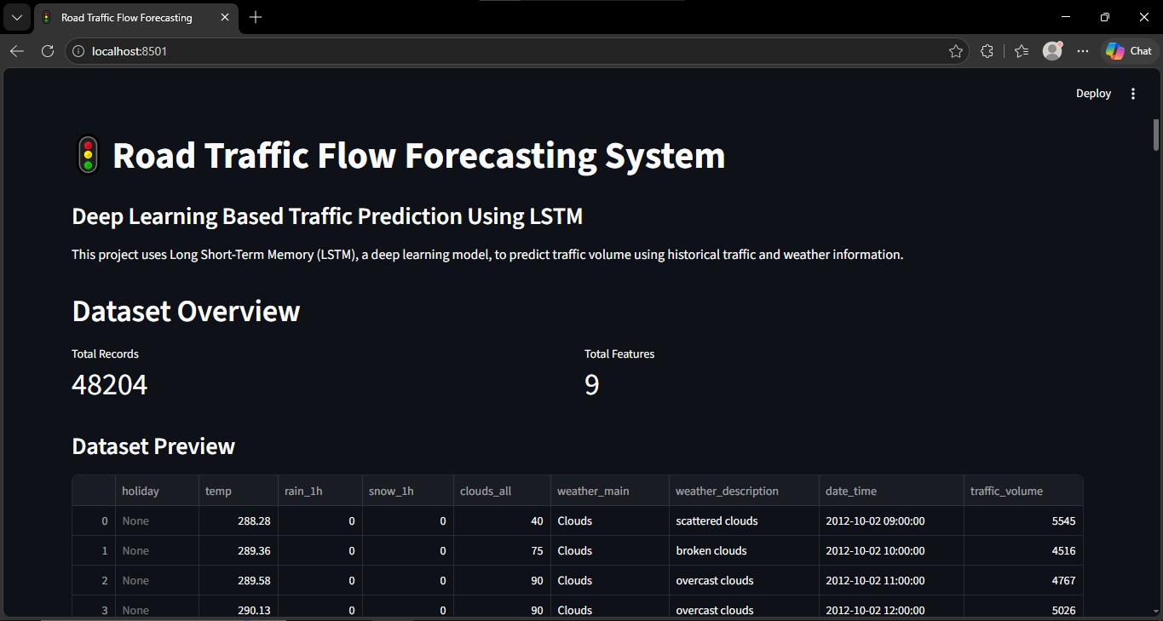

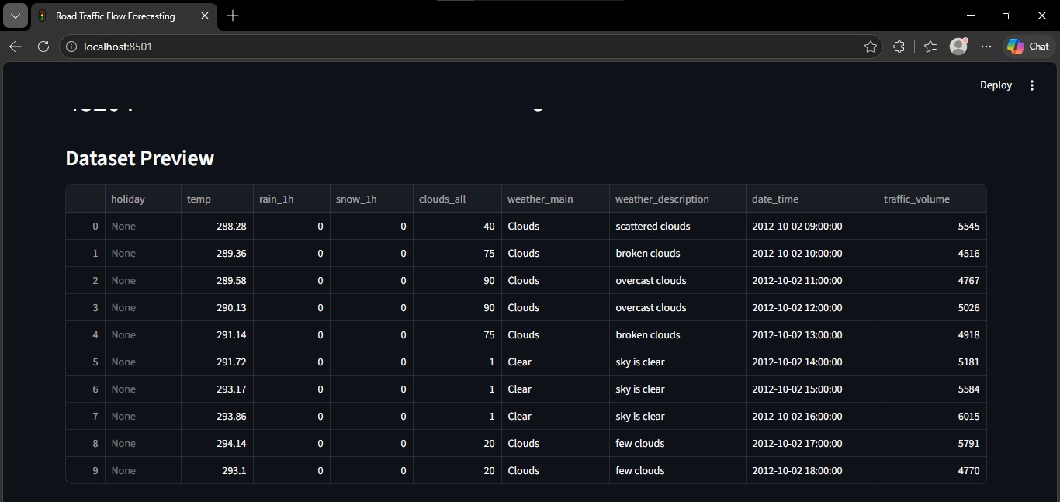

6. Explanation of Project (Working)
The working of the Road Traffic Flow Forecasting system begins with loading historical traffic data from a CSV file. The dataset contains observations recorded at different time intervals. The data is checked for missing values, duplicate records, incorrect formats, and invalid observations. The timestamp column is converted into datetime format and the records are arranged in chronological order.
After cleaning, the traffic-volume values are scaled to a suitable numerical range. This helps the neural network train more effectively. The scaled time series is then divided into sequences. Each sequence contains a fixed number of previous traffic observations, and the corresponding target is the next traffic observation.
The prepared sequences are divided into training and testing sets in chronological order. The LSTM model is trained using the training sequences. During training, the network adjusts its internal weights to reduce the difference between its predicted traffic values and the actual values.
After training, the model predicts traffic volume for the test period. The predictions are transformed back to the original scale so that they can be interpreted in the dataset's units. The system calculates evaluation metrics such as MAE, MSE, and RMSE.
Finally, a graph is generated to compare actual traffic flow with predicted traffic flow. This comparison helps show whether the model follows the overall trend and where prediction errors occur. The forecast can be used for analysis and planning, subject to the limitations of the available data.

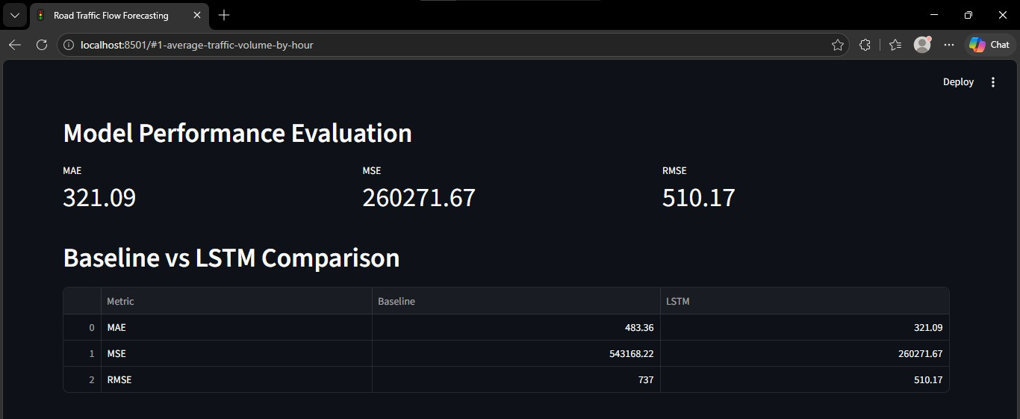
Average traffic volume by hour
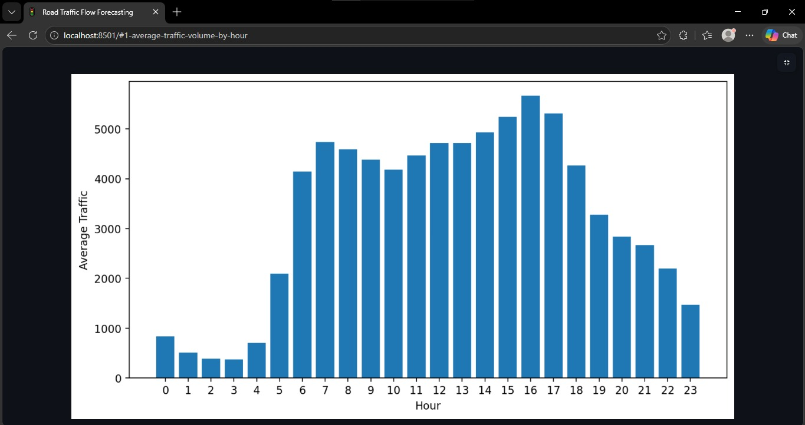
Traffic volume over time
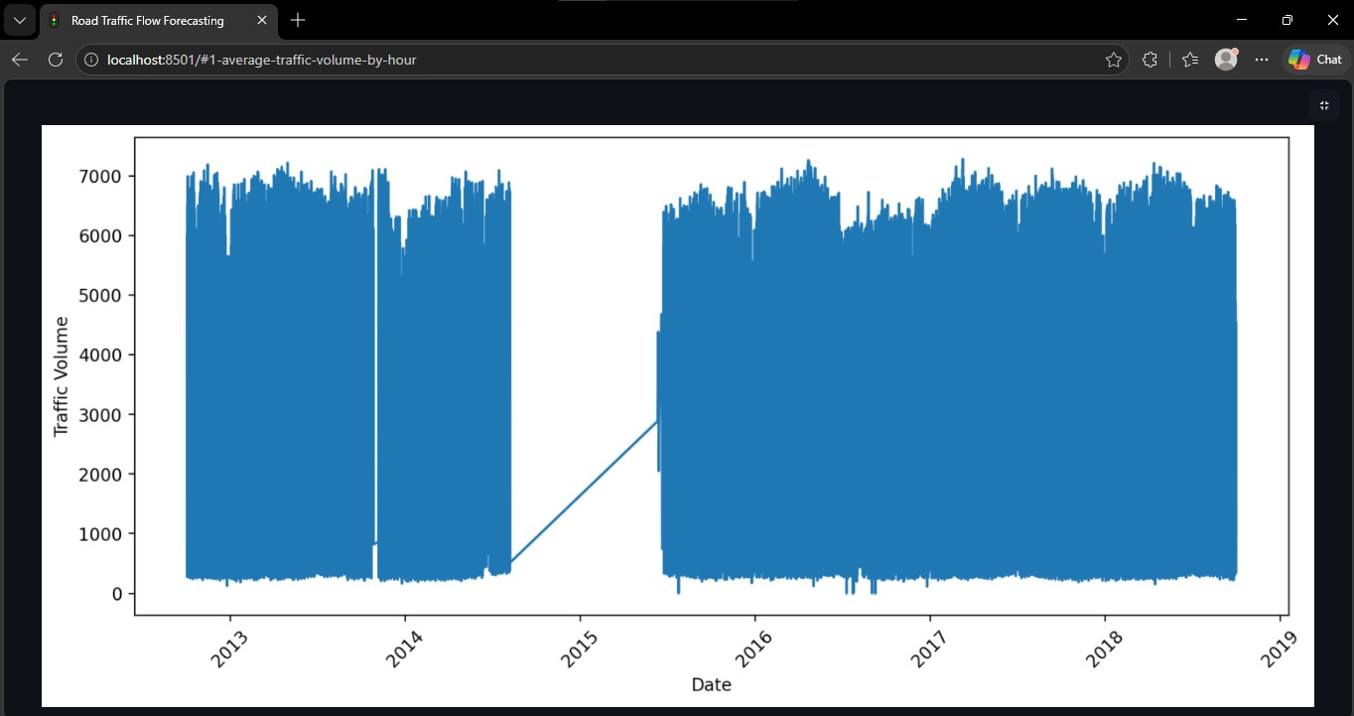
Average traffic by day of week
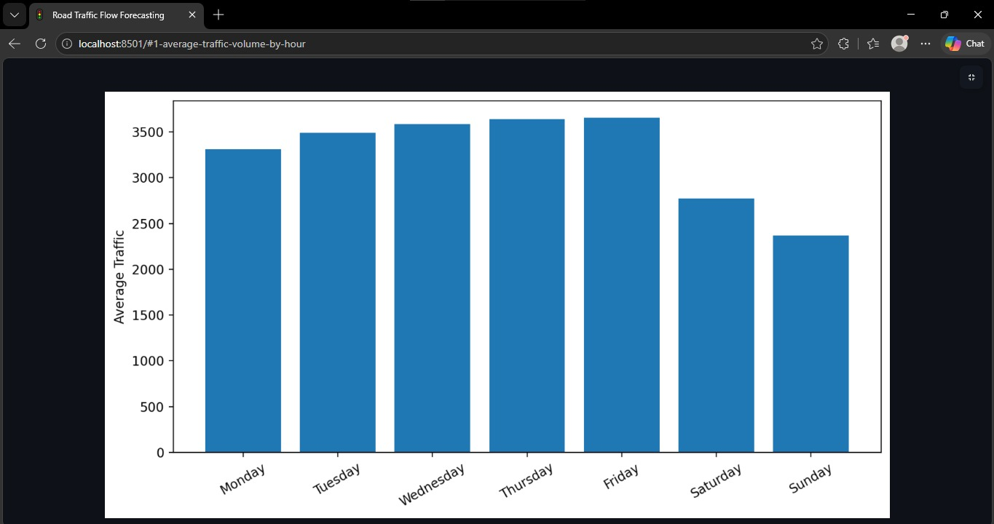

7. Workflow

- Start the project.
- Import required Python libraries.
- Load the historical traffic dataset.
- Inspect and preprocess the data.
- Sort traffic observations by timestamp.
- Scale the traffic-volume values.
- Create time-series input sequences.
- Split the sequences chronologically into training and testing sets.
- Build and compile the LSTM model.
- Train the model using training data.
- Predict traffic flow for the test period.
- Convert predictions back to the original scale.
- Calculate MAE, MSE, and RMSE.
- Plot actual traffic flow against predicted traffic flow.
- Display and interpret the forecasting results.
- End.

8. Program
The following example demonstrates an LSTM traffic-flow forecasting workflow. It expects a CSV dataset named traffic.csv with a timestamp column and a traffic_volume column. If the dataset uses different column names, update the names in the code. The example is intended as a starting implementation; actual results depend on the dataset.
import numpy as np
import pandas as pd
import joblib

from sklearn.preprocessing import MinMaxScaler
from tensorflow.keras.models import Sequential
from tensorflow.keras.layers import LSTM, Dense, Input

# 1. Load dataset
data = pd.read_csv("traffic.csv")

# 2. Extract time features
data['date_time'] = pd.to_datetime(data['date_time'])
data['hour'] = data['date_time'].dt.hour
data['day_of_week'] = data['date_time'].dt.dayofweek

# 3. Select numerical features
features = [
'traffic_volume',
'temp',
'rain_1h',
'snow_1h',
'clouds_all',
'hour',
'day_of_week'
]

values = data[features].values

# 4. Scale data
time_steps = 10

split = int((len(values) - time_steps) * 0.8)
train_end = split + time_steps

scaler = MinMaxScaler()
scaler.fit(values[:train_end])

scaled_data = scaler.transform(values)

# 5. Create sequences
X = []
y = []

for i in range(time_steps, len(scaled_data)):
X.append(scaled_data[i-time_steps:i])
y.append(scaled_data[i, 0])

X = np.array(X)
y = np.array(y)

# 6. Split data chronologically
split = int(len(X) * 0.8)

X_train = X[:split]
X_test = X[split:]

y_train = y[:split]
y_test = y[split:]

# 7. Build LSTM model
model = Sequential([
Input(shape=(time_steps, len(features))),
LSTM(32),
Dense(16, activation='relu'),
Dense(1)
])

# 8. Compile model
model.compile(optimizer='adam', loss='mse')

# 9. Train model
print("Training LSTM model...")

model.fit(
X_train,
y_train,
epochs=3,
batch_size=64,
verbose=1
)

# 10. Save model and scaler
model.save("traffic_lstm.keras")
joblib.dump(scaler, "traffic_scaler.save")

print("LSTM model trained and saved successfully!")

////Trained Model///
import numpy as np
import pandas as pd
import joblib

from sklearn.preprocessing import MinMaxScaler
from tensorflow.keras.models import Sequential
from tensorflow.keras.layers import Dense

data = pd.read_csv("traffic.csv")
data['hour'] = pd.to_datetime(data['date_time']).dt.hour
# Dummy rain feature (you can improve later)
data['rain'] = np.random.randint(0, 2, len(data))

X = data[['hour', 'rain']].values
y = data['traffic_volume'].values.reshape(-1, 1)

scaler_X = MinMaxScaler()
scaler_y = MinMaxScaler()

X_scaled = scaler_X.fit_transform(X)
y_scaled = scaler_y.fit_transform(y)

model = Sequential()
model.add(Dense(32, activation='relu', input_dim=2))
model.add(Dense(16, activation='relu'))
model.add(Dense(1))

model.compile(optimizer='adam', loss='mse')

model.fit(X_scaled, y_scaled, epochs=20)
model.save("traffic_model.h5")
joblib.dump(scaler_X, "scaler_X.save")
joblib.dump(scaler_y, "scaler_y.save")

print("✅ Model trained with weather feature!")

9. Result & Discussions
The project produces predicted traffic-volume values for the test period using the trained LSTM model. The actual and predicted values can be displayed on the same line graph to observe how closely the forecast follows the traffic pattern. The model evaluation metrics provide a numerical summary of prediction error.
Mean Absolute Error (MAE) represents the average magnitude of errors without considering their direction. Mean Squared Error (MSE) gives larger errors more weight because the errors are squared. Root Mean Squared Error (RMSE) is the square root of MSE and is expressed in the same unit as the traffic-volume variable.
- A line graph can show whether the predicted series follows the overall movement of actual traffic flow.
- Small MAE and RMSE values indicate lower prediction error for the evaluated test period.
- Large differences between actual and predicted values may occur during sudden traffic changes or unusual events.
- Results depend on dataset size, data quality, observation interval, selected sequence length, and model parameters.
- Numerical performance values should be filled in only after running the program on the selected traffic dataset.

Actual vs Pridiction traffic graph
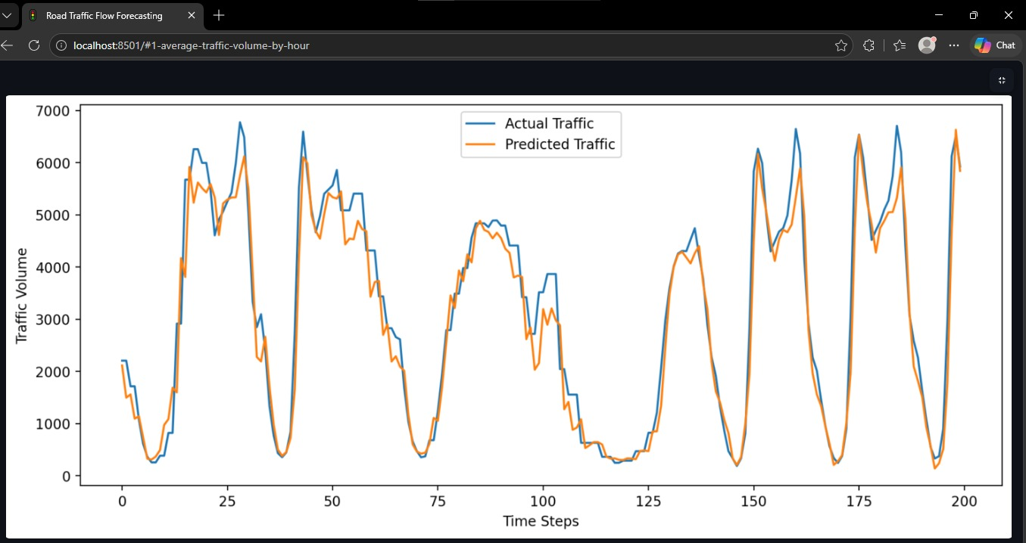

10. Snippets of UI / Output
The project can display the following outputs after successful execution:
- Dataset preview showing timestamp and traffic-volume columns.
- Traffic-volume trend graph over time.
- Training and validation loss graph.
- Actual versus predicted traffic-flow graph.
- Console output showing MAE, MSE, and RMSE.

Sample output format
MAE: <value calculated after execution>
MSE: <value calculated after execution>
RMSE: <value calculated after execution>
The values above are placeholders, not actual model results. Screenshots of the real graphs and console output should be inserted after running the project in VS Code or Jupyter Notebook.

Suggested interface fields
- Dataset upload or dataset selection.
- Traffic volume history graph.
- Forecast horizon or number of future time steps.
- Predicted traffic-flow value.
- Actual-versus-predicted comparison chart.

11. Future Scope
1. Real-Time Traffic Prediction: In the future, the system can be enhanced to predict traffic conditions in real time using live traffic data.
2. AI and Machine Learning: Advanced machine learning and deep learning algorithms can be implemented to improve prediction accuracy.
3. GPS Integration: GPS technology can be integrated to track vehicle locations and identify traffic congestion.
4. Smart Traffic Signals: The system can be connected with smart traffic signals to automatically manage traffic flow.
5. Weather Integration: Weather conditions such as rain, fog, and storms can be considered to improve traffic predictions.
6. Mobile Application: A mobile application can be developed to provide traffic updates and suggest alternative routes to users.
7. Accident Detection: The system can be extended to detect accidents and alert nearby authorities.
8. Scalability: In the future, the project can be expanded to cover multiple cities and highways.
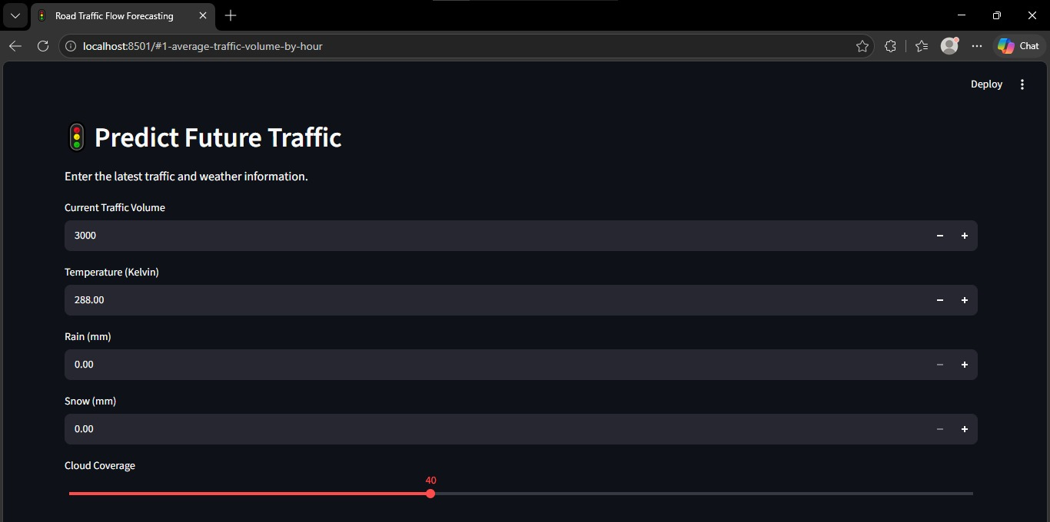

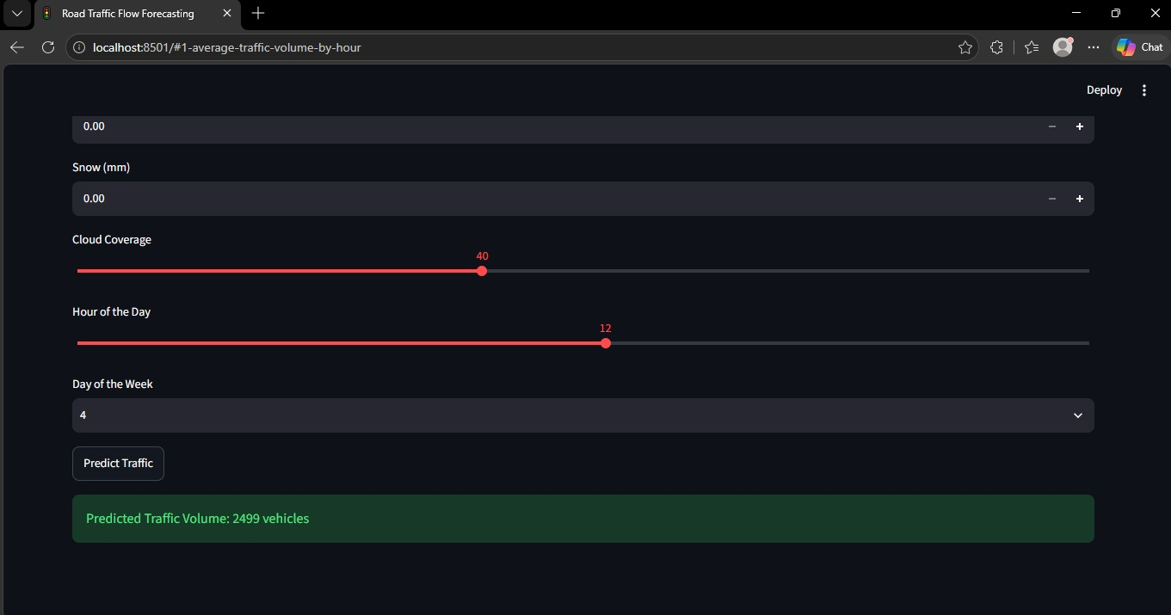

12. Conclusion
This project presents a deep learning-based approach for road traffic flow forecasting using Long Short-Term Memory (LSTM). The system uses historical traffic observations to learn time-dependent patterns and predict future traffic volume. The project workflow includes data collection, preprocessing, sequence creation, model training, prediction, evaluation, and visualization.
LSTM is suitable for this task because it is designed to learn sequential relationships in time-series data. By comparing actual traffic values with predicted values and calculating error metrics such as MAE, MSE, and RMSE, the performance of the forecasting model can be assessed on unseen observations.
The system can help users understand traffic trends and may support traffic planning by providing estimates of upcoming traffic flow. Its reliability depends on the quality and coverage of the dataset, model configuration, and changing road conditions. Real-time data integration and further model improvements can make the system more useful in future intelligent transportation applications.
Overall, Road Traffic Flow Forecasting with LSTM demonstrates the application of deep learning in transportation analytics and provides a foundation for developing smarter, more efficient traffic-management solutions.

